Customer Behavior Analysis
Project Overview
This project explores and analyzes a retail customer shopping behavior dataset to help a company better understand how customers interact with its products, discounts, and subscription programs
Dataset exploration
Rows: 3,900
Columns: 18
Categorical Columns : gender, item_purchased, category, location , size, color, season , subscription_status , discount_applied, payment_method, frequency_of_purchases , age_group
Numerical Columns : customer_id, purchase_amount,review_rating,previous_purchases,purchase_frequency_days
Missing_values : 37 values in the Review Rating column
1.Data loading : a csv file using python : pandas
Exploration : using.info() and .describe() for summary statistics

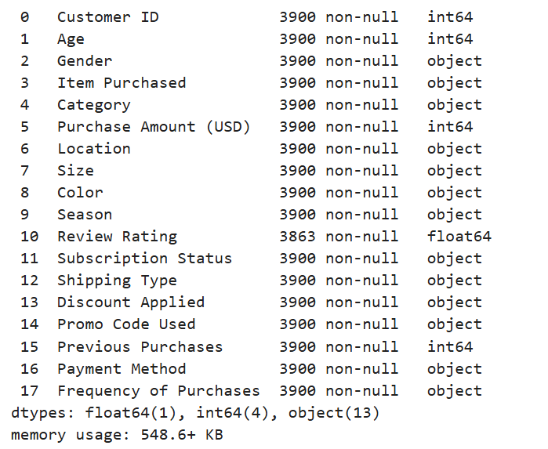
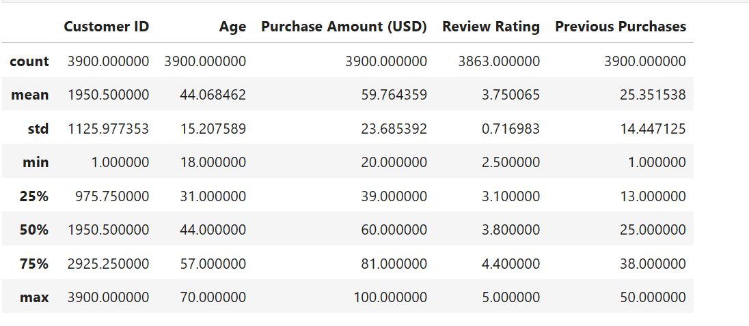
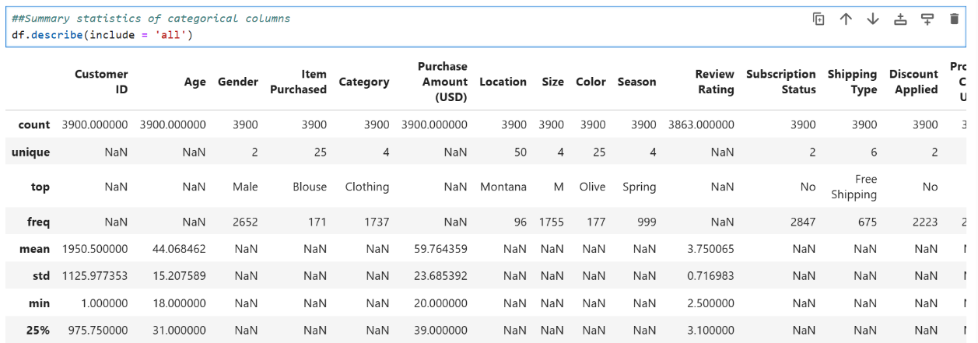

Data Cleaning :
- Missing values : used median to replace the nulls for each product category in the column Review Rating
- Renamed columns by removing spaces between words and replaced it with”_” for a better handling
- Suppression of the column promo_code_used as it had the same values and the same purpose In this dataset as the column discount_applied
- Feature engineering : 2 columns were added : age_group ( categorizing customer ages) , and purchase_frequency_days from purchase_data

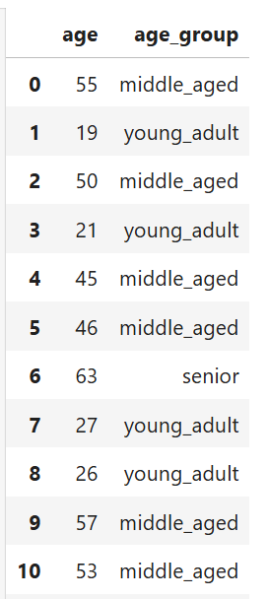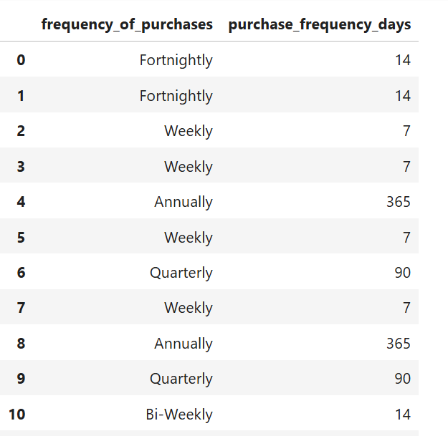

Database Upload

Connecting Python to SQL Server (SSMS)

Data analysis using sql in ssms
Revenue by Gender : total revenue generated from both gender
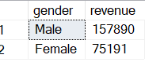
High-Spending Discounted : customers that surpassed the average purchase amount despite using discounts
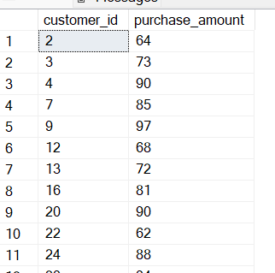
Top 5 Rated Products : highest reviews
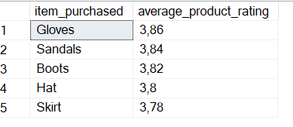
Shipping Comparison : shipping type comparaison based on purchase amount
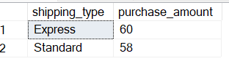
Subscription Spending : total customers and revenues of subscribed vs non subscribed customers
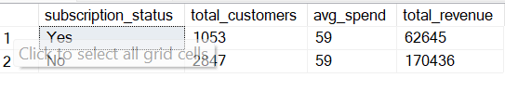
Discount Percentage : top 5 products with the highest % of discounted purchases
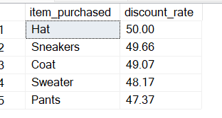
Customer Segmentation : segmentation of customers based on purchase amount
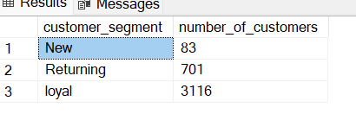
Top Products : top 3 products per each category based on total orders
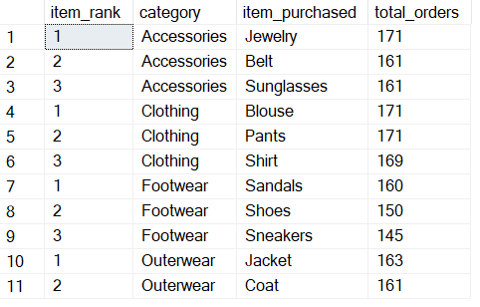
Repeat Subscribers : most repeated buyers are not subscribed
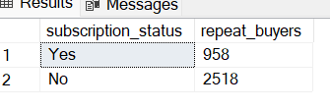
Revenue by Age group : contribution of each group to revenue generation , young adults being the top contributors
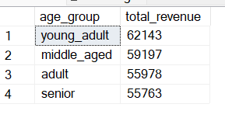
Visualisations : dashboard power bi

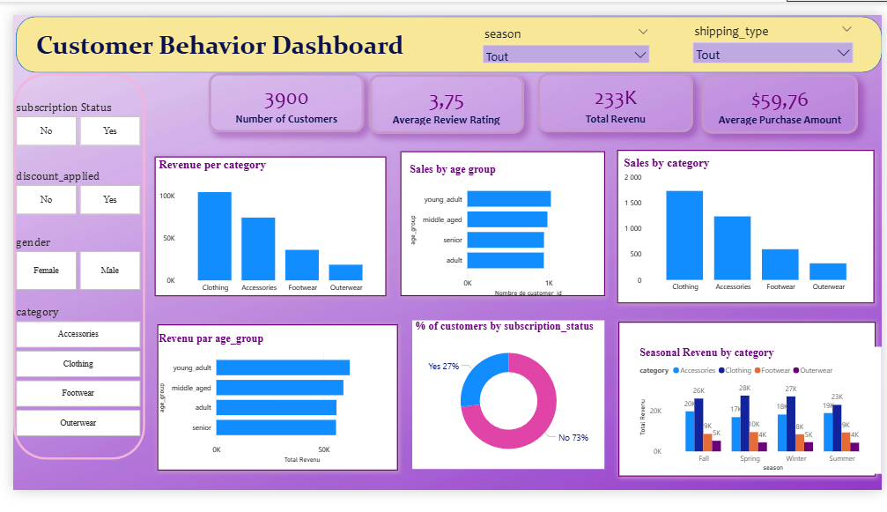

Key Insights
- 🛍️ Clothing and Accessories are the most purchased categories.
- 💸Young adults and middle-aged customers are the main contributors to revenue.
- 🔁 Repeat buyers are more likely to be subscribed customers.
- The majority of the customer base remain unsubscribed.

